create database AnudipLab;

use AnudipLab;

create table Customer(customer_id int primary key,first_name varchar(20),Last_name varchar(30));

insert into Customer values(1,'ROHIT','SINGH');

insert into Customer values(2,'SOHIT','SINGH');

create table Orders(order_id int primary key,order_date date,Total_amount int,customer_id int,foreign key(customer_id) references Customer(customer_id));

insert into Orders values(100,'2024-10-24','9000','1');

insert into Orders values(200,'2024-10-25','8000','1');

insert into Orders values(300,'2024-10-24','7000','2');

SELECT customers.first_name, customers.last_name, orders.order_date, orders.total_amount

FROM Customer AS customers

INNER JOIN Orders AS orders ON customers.customer_id = orders.customer_id;

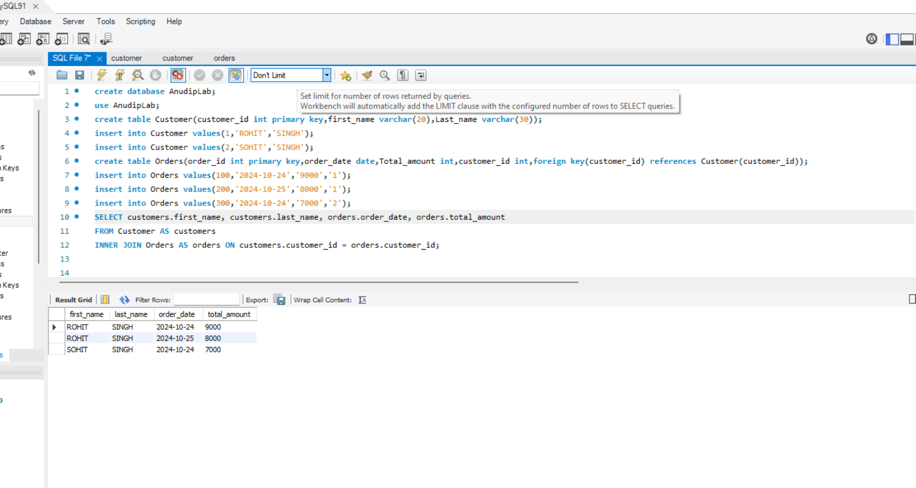

create database AnudipLab;

use AnudipLab;

create table Department(department_id int primary key,department_name varchar(30));

insert into Department values(101,'ECE');

insert into Department values(102,'CSE');

Create table Employees(employee_id int primary key,first_name varchar(30),last_name varchar(30),department_id int,foreign key(department_id) references Department(department_id));

insert into Employees values(1,'ADITYA','KESHARI','101');

insert into Employees values(2,'ADITI','KESHARI','102');

SELECT Department.department_name, employees.first_name, employees.last_name

FROM Department

left JOIN employees ON Department.department_id = employees.department_id;

